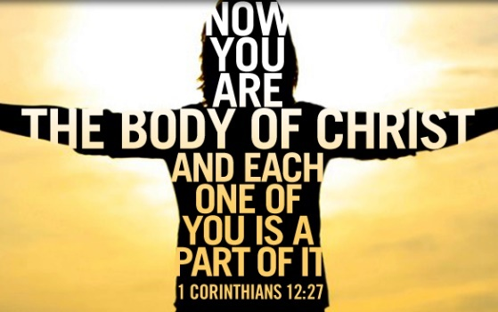
Jesus Only? – or – Jesus, And?
June 2023

Jesus is all you need – just have more faith; pray more; go to church more; worship more; read the Bible more….

Wait, what??

Did I catch your attention? I sure hope so because if I can do anything for you – I hope I can help bust a myth that generates more damage than it does support to the person who receives it.

I absolutely agree that Jesus is all you need. Strip everything else away and if you only have Jesus left – yes, you have what you need… for salvation; for eternity in Heaven; for fulfillment; for peace and freedom from the shackles of sin.

But friends, to be in the presence of someone who is struggling through any given hardship – it is unfair to deal them a card which suggests he/she must achieve a level of “enough” to escape life’s hurts, hardship, or struggle. There is no way to escape trouble in this world (John 16:33) and while Jesus certainly is the way, the truth, and the life (John 14:6) – He provides you and I with resources and a slew of helps to cope through the trouble of the world.

You see, as believers, we get to proclaim yes! – Jesus is my all in all – and in my struggles, He has provided me with [a pastor, a counselor, a therapist, a doctor, a specialist, a nurse…] to strengthen who He has created me to be in the face of some really heavy, painful things.

Did you catch that? Did you catch the and? Did you make the connection that the Lord is enough, and He uses His people to speak life, love, hope and peace into your day-to-day? Loving the Lord with all your heart, mind, soul, and strength does not exempt you from physical, emotional, relational, mental, or spiritual battles which are the result of being born into a broken, sinful world. Loving the Lord, however, does mean there is an entire Body suited with gifts to support the weaker parts and never, do the parts ever, function on their own apart from the Body of which Christ is the Head (Colossians 1:18).

The bottom line that I want you to catch is this: 1). Jesus is enough; and 2). He has equipped people to walk with you through the storms, fires, droughts, and floods of your lives. That is specifically why I am here as the Family, Life & Ministry of Care Provider at First Reformed and for our community. I, in my brokenness, am here in this place to walk with you through yours; to give you space to share in a confidential, judgement-free setting; to use my experiences, education, and practice to support you for as long as you need.

I am praying the Lord gives you the courage and strength to reach out. And if not you, that you will encourage your hurting friends and family members to connect soon.

For Him,

Anita Van Veldhuizen Email: anita.vanv@yahoo.com
Family, Life, & Ministry of Care Provider Call/Text: (712) 540-1521

