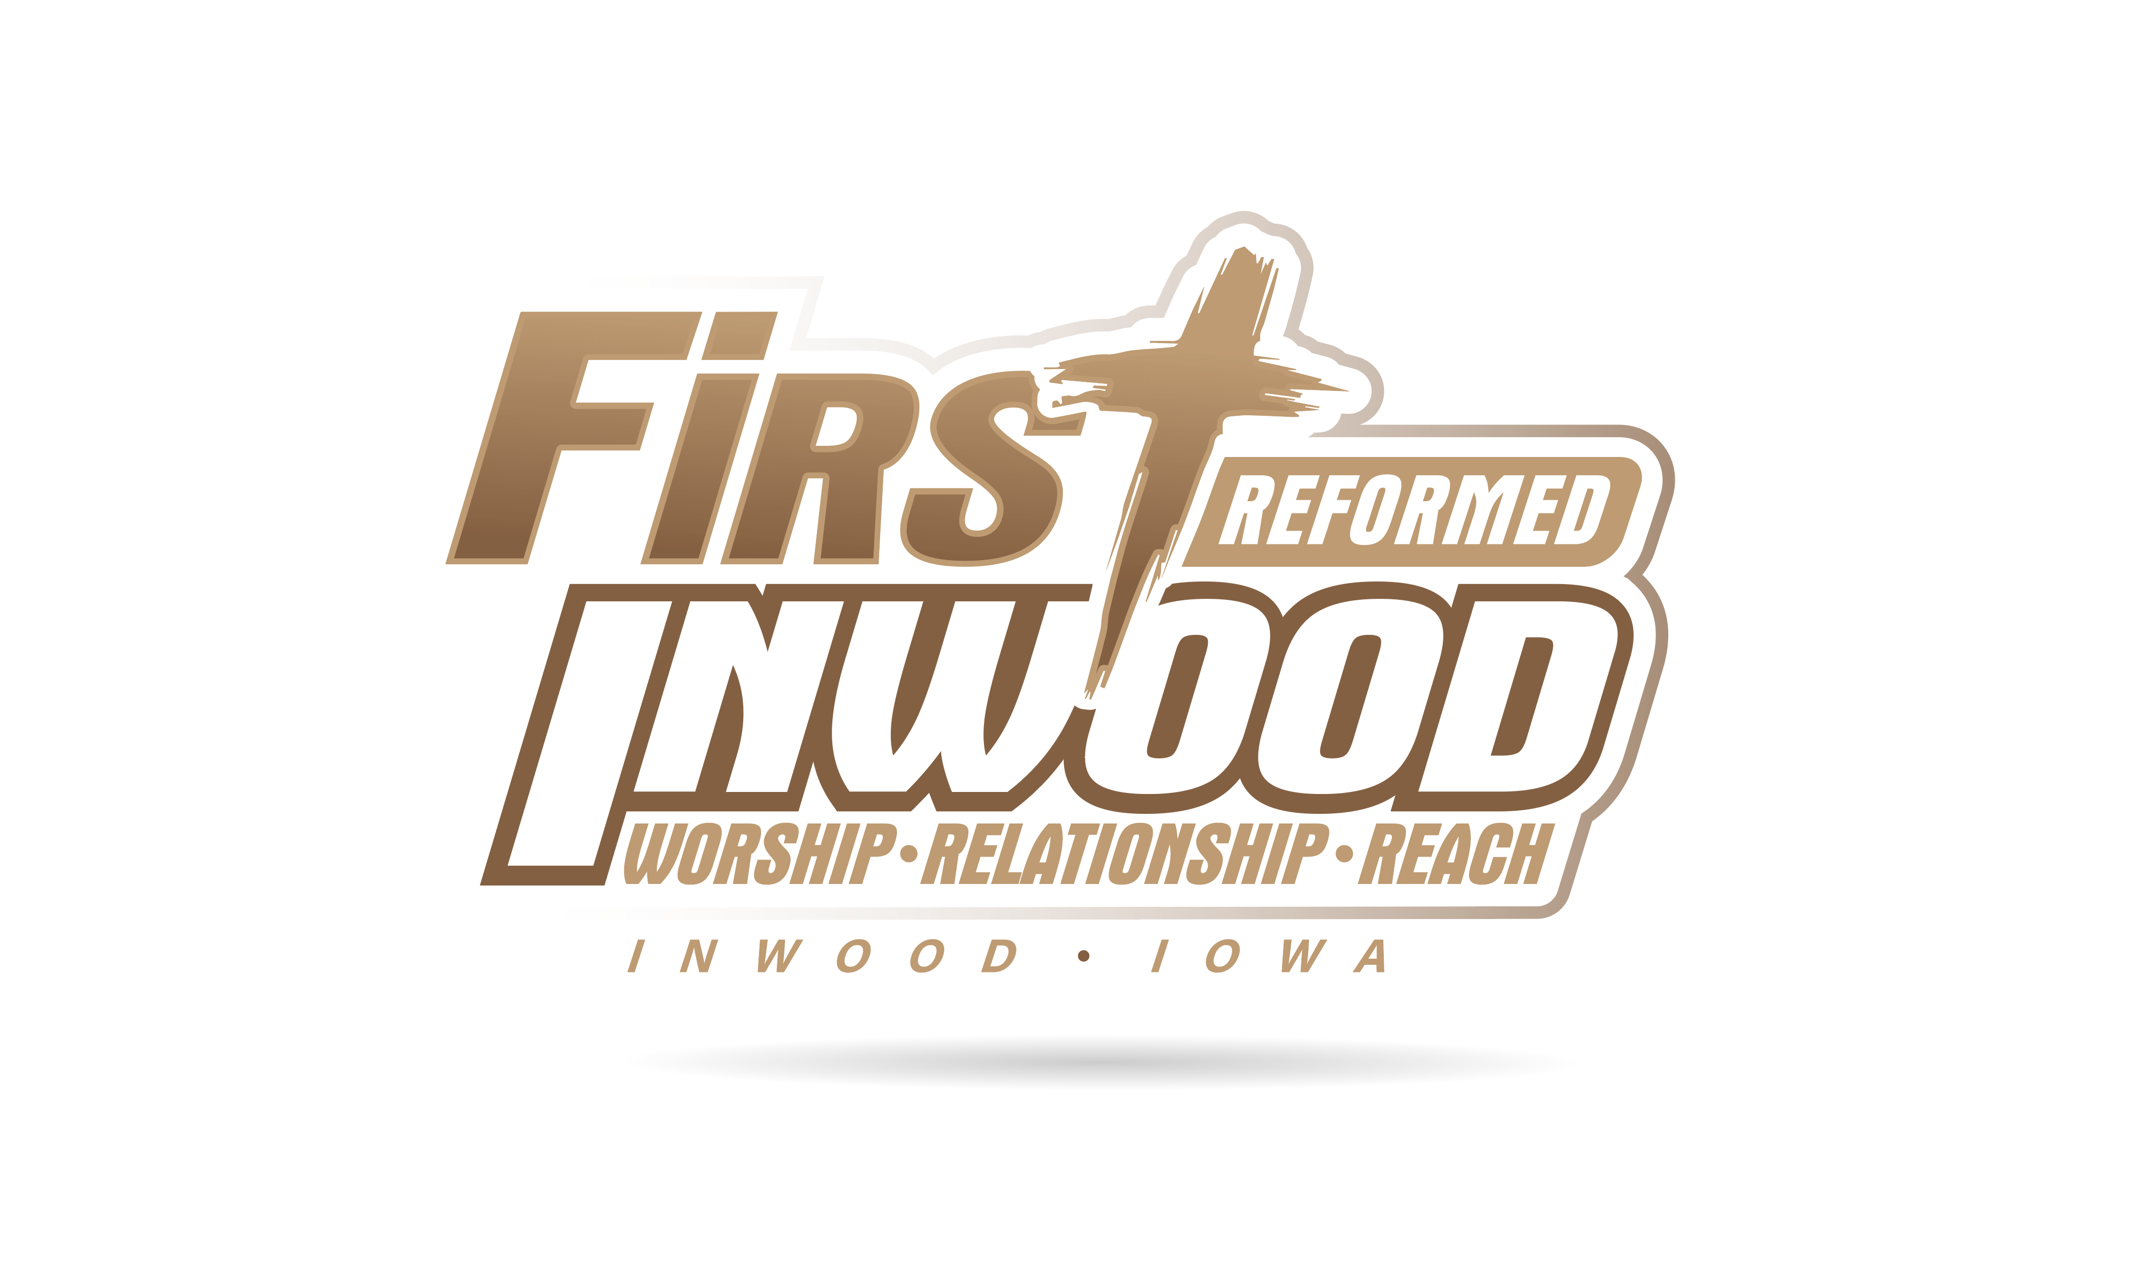

414 N. Oak St. PO Box 279
Inwood, Iowa 51240
Pastor Rob’s Office: (712)-753-2347
Church Office: (712)-753-4818
Church Janitor (Sandy) (712)753-2367
E-mail: frcinwood@gmail.com
Pastor Rob’s Email: pastorrob@alliancecom.net

www.frcinwood.org

FOLLOWING CHRIST IN MISSION

Morning Celebration 9:30 a.m.
Fellowship 10:30 a.m.

FIRST REFORMED CHURCH
SUNDAY MORNING CELEBRATION
Sunday, June 9, 2019 9:30 AM

WE PREPARE TO PRAISE GOD
Prelude
Welcome and announcements Pastor Rob Horstman
*GREETINGS (*Those who are able please stand)
*CALL TO WORSHIP
WE COME TO GOD WITH PRAISE, PRAYERS, AND GIFTS
*PRAISE SONGS and PRAYER “Our God Reigns” #268
“We Believe” Power Point
SPECIAL MUSIC VBS Kids
RECEIVING GOD’S GOOD NEWS
CHILDREN’S MESSAGE
~Children age 3 years – 3rd grade are dismissed for Veggie Time

MESSAGE “Give Us Today Our Daily Bread!”
The Lord’s Prayer Sermon Series
Bible Text: Matthew 6:11, 15:32 – 39; Proverbs 30:8 – 9
The Heidelberg Catechism Q & A 125
COMMUNION
SO WE CAN JOYFULLY RESPOND IN CHRIST’S NAME
GIVING OF TITHES AND OFFERINGS

MORNING PRAYER
*BENEDICTION *SONG OF PARTING “Praise God from Whom All Blessings Flow” #7
*POSTLUDE

WELCOME TO FIRST REFORMED CHURCH!

9:30 A.M. Morning Celebration. Pastor Rob Horstman will share the message
Greeters: Shirley Addink & Forrest Kent Organist: Irene Ter Wee
Fellowship Cookies provided by Karen Van Ginkel & Jessie Van Wyk
Healthy snacks provided by Sandy Van Tol
Nursery Caregivers: Jodi Faber, Sherry Carolan, Hadley Dake
Veggie Time Volunteers: Kelsey Oye, Mike Rozeboom, Hadley Dake

NEXT SUNDAY ~ June 16
9:30 A.M. Morning Celebration. Pastor Rob Horstman will share the message
Greeters: Jody Dieters & Betty Teunissen Organist: Amber Van Essen
Fellowship Cookies provided by Darwin Ver Hoeven & Mark Koedam
Healthy snacks provided by Eileen Denekas
Nursery Caregivers: Natalie Bohlke, Liz Bonestroo, Addison Brower
Veggie Time Volunteers: Ann Rozeboom, Chloe Van Essen, Breanna Faber

Congregational NEWS
The Calling Team for this month is Jesse Moser and Lance Van Roekel.
Reminder: On June 12 the Elders’ will meet at 7:00 and the full consistory will meet at 7:30 for their regular meetings.
Pastor Rob will be gone on vacation from June 17 through June 25. If you have a pastoral concern, contact the calling team or a consistory member.
SUMMER IS HERE! That means it’s time for Church camps! We have a handful of young people attending camp this summer and we would like to invite the FRC church family to write them notes of encouragement while they are attending camp!
Kendra Van Regenmorter will be attending camp the week of June 17 – 21.
Please have your notes in Courtnie Fleshman’s mailbox by SUNDAY, JUNE 16! Please make sure to put the campers name and what day of the week you would like them to receive the note (PS - Tues - Thurs are usually the best days!) Also know, this doesn’t have to just be from individuals/families. These notes can be from groups of people as well- women’s group, bible study groups, etc. If you have any questions, please let Courtnie Fleshman know! Thanks everyone!

Sermon and Worship Service videos/audio can be found on the
First Reformed Church Website - www.frcinwood.org

JOYS & CONCERNS

- We extend our sympathies to Dawn & Paul Van Beek in the passing of Dawn’s mother, Karen Calsbeek. Karen’s funeral was held this past Friday in Rock Valley. We also extend our sympathies to Brady & Mariah Van Beek in the loss of Brady’s grandmother.

- Jeanette Spaans’ dad continues to recover from a broken back he suffered in an auto accident a couple of weeks ago. Keep him in your prayers.

- Melissa Moser will be traveling to Iowa City next week to take her first round of the new trial treatment. Pray that she can receive the treatment and that there will be little to no side effects. Keep Jesse and the rest of her family in your prayers as well.

- Loren Klarenbeek is scheduled for surgery on June 17 to repair a hole between the two chambers in his heart. Pray for surgery to go well.

- Randy Van Hill will have an angiogram on June 12 to determine some issues with his heart.

- Pray for those undergoing treatment for cancer – Merle Tilstra, Ron Zylstra, Melissa Moser, and others from our families and communities.

- Pray for Howard Koedam as he suffered some brain bleeds due to a fall a couple of weeks ago. He has a long road to recovery in front of him.

- Jake Dieters is undergoing tests to determine what the growth on his kidney is. Keep him in your prayers.

- Continue to pray for our crop & livestock farmers as it has been a challenging year.

24th Annual Hope Haven Gospel Sing Benefit
Will be held at Central Park in Sioux Center on Friday and Saturday, June 21 & 22 with great continuous music from 1:00 – 9:30 pm on Friday and 11:00 am – 9:30 pm on Saturday.
A lunch stand will be open both days.
Freewill Offering for Hope Haven will be taken each day. Rain site: Dordt College Rec Center

Volunteers Needed Various weeks June 10 – August 2
With record breaking campers coming, Inspiration Hills is looking for people to help out a few weeks as a volunteer counselor! If you or someone you know are free for a week and would love to invest in kids, come join us! You are welcome to spend the evenings here, but it is not required.
Please call the office at 712-986-5193 or email ihills@inspirationhills.org if interested.

The Memory Loss Support Group will be meeting on Wednesday, June 12, 2019 at 1:00 pm at Whispering Heights. This Support Group is open to anyone who lives with or cares for someone affected by dementia. For more information, please contact Melinda at 712-476-8214. New members always welcome!

Camp Sunday June 9th
Inspiration Hills welcomes ALL FAMILIES to our Camp Sunday June 9th, from 3pm-5pm! Meet our Summer Camp Staff, enjoy some NEW camp activities, & explore where the campers will spend their time this summer! Tours are available throughout the afternoon! Take along your Swimsuit & Towel to enjoy the Pool & Slip-N-Slide! Bring the WHOLE family for this FREE event!
RSVP to enter in for a prize by calling at 712-986-5193 or emailing at ihills@inspirationhills.org

The Inwood Christian School Board will be meeting Monday evening, June 10, at 7:00 p.m. in the school office.

Our Leadership Team
Rob Horstman, Pastor and President*
Pastor Rob’s Office (712)-753-2347 ~ Pastor Rob’s Email: pastorrob@alliancecom.net

Elders Deacons
Phil Brower, ‘22 Jake Erpenbach, ‘22
*Jesse Moser, ’20, VP Terry Teunissen, ‘22
James Van Ginkel, ’21 Keith Van Der Brink, ‘20
Chad Van Regenmorter, ’20 Randy Van Hill. ‘21
*Mark Van Tol, ’22, Clerk *Lance Van Roekel, ’20, Head Deacon

* Executive Committee Members
The Elders and Deacons meet monthly the third Wednesday at 7:30 p.m.

Ministry Area Coordinators
Buildings & Grounds: Keith Van Der Brink Education: Eileen Denekas
Mission: Gail Harmelink Outreach: Jody Van Regenmorter Worship: Dori Horstman
Sound & Video: Chris Lapka Fellowship: Courtnie Fleshman

Ministry Support Staff
Youth Director: Anita VanVeldhuizen ~ anita.vanv@yahoo.com
Secretary: Bonnie Van Ginkel
Custodian: Sandy Van Tol
Accompanists: Courtnie Fleshman, Amber Van Essen, Irene Ter Wee,
Phil Brouwer, Rebecca Van Regenmorter, Regan Claus
Praise Team Leader/Accompanist: Courtnie Fleshman
Sound Technician: Janice Ver Hoeven
Treasurer: Bonnie Van Ginkel
Missionaries We Help Support
Brian and Donna Renes and family Roger and Karen Van Otterloo and family

OUR MISSION STATEMENT
In the name of Christ, First Reformed Church desires to
proclaim God’s word, worship God’s name, and live as His disciples,
united through prayer, fellowship, and service.

OUR VISION STATEMENT
Imagine in our church a
Fellowship of believers who
Reach out to those in need and yet
Cultivate the ministry of fellow Christians
APRIL 23

Sunday Offering Schedule
1st Sunday is for the general fund as well as the Benevolent Fund, and Children’s Coin Offering
2nd and 3rd Sundays are for the General Fund
4th Sunday is for the general fund as well as the Building Fund
5th Sunday is for the General Fund as well as a special offering that is determined by the deacons

