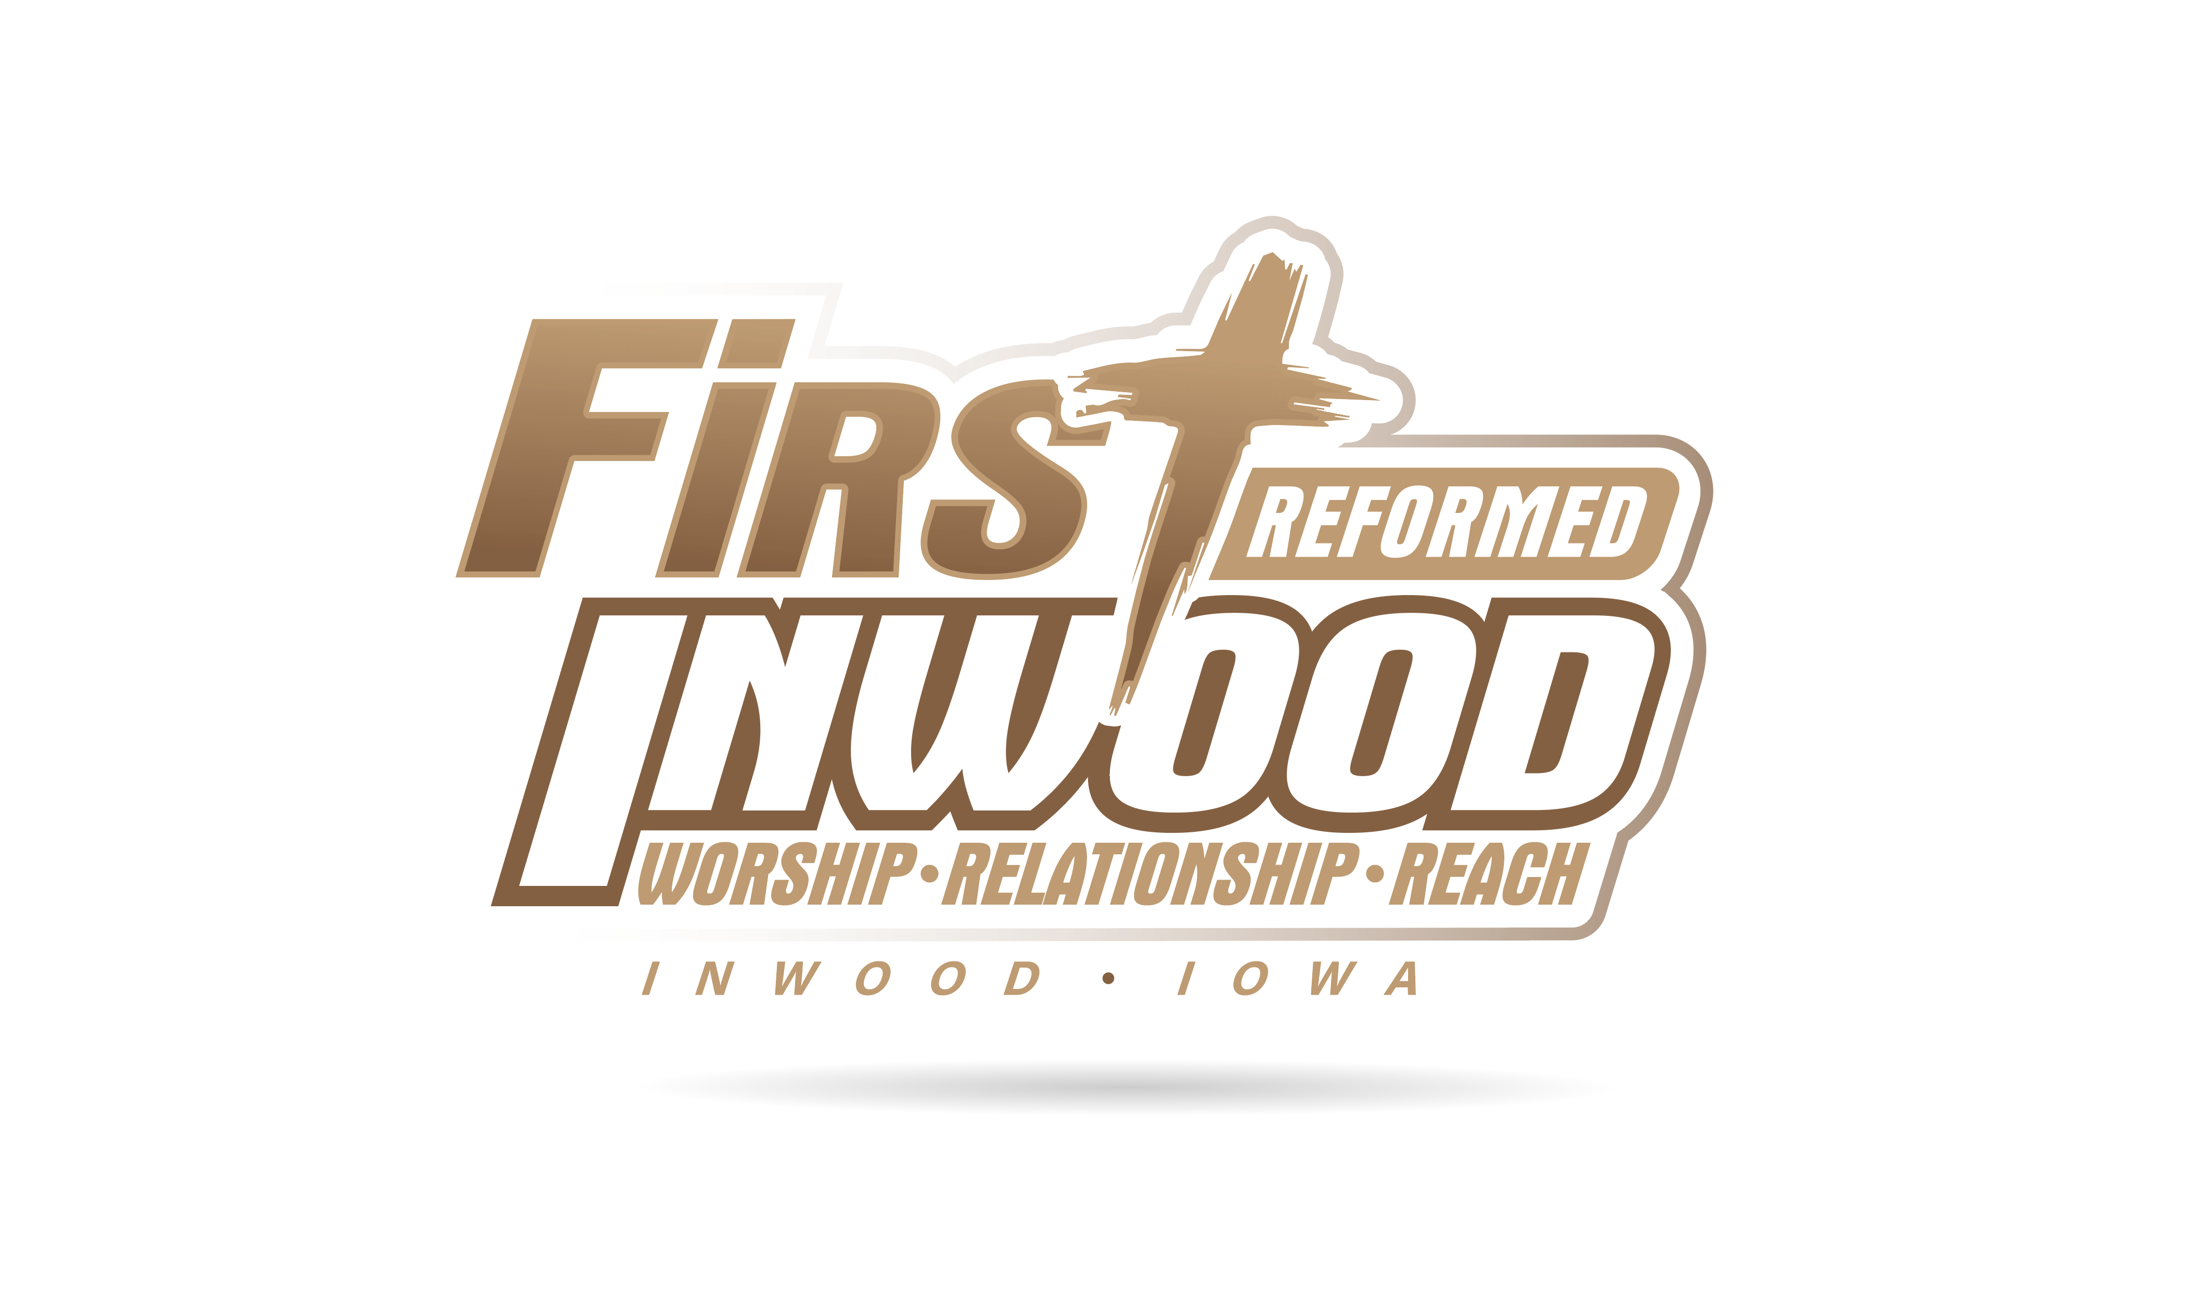

414 N. Oak St. PO Box 279
Inwood, Iowa 51240
Pastor Rob’s Office: (712)-753-2347
Church Office: (712)-753-4818
Church Janitor (Sandy) (712)753-2367
E-mail: frcinwood@gmail.com
Pastor Rob’s Email: pastorrob@alliancecom.net

www.frcinwood.org

FOLLOWING CHRIST IN MISSION

Morning Celebration 9:30 a.m.
Fellowship 10:30 a.m.

FIRST REFORMED CHURCH
SUNDAY MORNING CELEBRATION
Sunday, June 2, 2019 9:30 AM

WE PREPARE TO PRAISE GOD
Prelude
Welcome and announcements Pastor Rob Horstman
*GREETINGS (*Those who are able please stand)
*CALL TO WORSHIP
WE COME TO GOD WITH PRAISE, PRAYERS, AND GIFTS
*PRAISE SONGS and PRAYER “There is Power in the Blood” #449
“Holy Spirit” Power Point
COMMUNION PREPARATORY
PRAYER OF CONFESSION
RECEIVING GOD’S GOOD NEWS
CHILDREN’S MESSAGE ~ “Fill it to the Cap” Children’s Coin Offering
~Children age 3 years – 3rd grade are dismissed for Veggie Time

MESSAGE “Thy Kindgom Come, Thy Will be Done!”
The Lord’s Prayer Sermon Series
Bible Text: Matthew 6:10, 33; Luke 22:39 – 46
The Heidelberg Catechism Q & A 123 – 124
SO WE CAN JOYFULLY RESPOND IN CHRIST’S NAME
GIVING OF TITHES AND OFFERINGS ~ Second Offering for the Benevolent Fund

MORNING PRAYER
*BENEDICTION *SONG OF PARTING “New Doxology” Power Point
*POSTLUDE

WELCOME TO FIRST REFORMED CHURCH!

9:30 A.M. Morning Celebration. Pastor Rob Horstman will share the message
Greeters: Jamie & Sherry Carolan Organist: Courtnie Fleshman
Fellowship Cookies provided by Janet Feikema & Katlyn Van Roekel
Healthy snacks provided by Lisa Van Regenmorter
Nursery Caregivers: Barb Hassebroek, Gail Harmelink, Danica Rozeboom
Veggie Time Volunteers: Katelyn Berentschot, Janette Boer, Angie & Rayna Van Bochove

NEXT SUNDAY ~ June 9
9:30 A.M. Morning Celebration. Pastor Rob Horstman will share the message
Greeters: Shirley Addink & Forrest Kent Organist: Irene Ter Wee
Fellowship Cookies provided by Karen Van Ginkel & Jessie Van Wyk
Healthy snacks provided by Sandy Van Tol
Nursery Caregivers: Jodi Faber, Sherry Carolan, Hadley Dake
Veggie Time Volunteers: Kelsey Oye, Mike Rozeboom, Hadley Dake

Congregational NEWS
The Calling Team for this month is Jesse Moser and Lance Van Roekel.
If you have an agenda item for the elder’s or consistory meetings next week, please let Pastor Rob know by Tuesday, June 7. If you are interested in becoming a member of First Reformed Church, visit with Pastor Rob or an elder for more information.
SUMMER IS HERE! That means it’s time for Church camps! We have a handful of young people attending camp this summer and we would like to invite the FRC church family to write them notes of encouragement while they are attending camp!
*Cody Van Regenmorter will be attending camp the week of June 10-14
Please have your notes in Courtnie Fleshman’s mailbox by SUNDAY, JUNE 9! Please make sure to put the campers name and what day of the week you would like them to receive the note (PS - Tues - Thurs are usually the best days!) Also know, this doesn’t have to just be from individuals/families. These notes can be from groups of people as well- women’s group, bible study groups, etc. If you have any questions, please let Courtnie Fleshman know! Thanks everyone!

Sermon and Worship Service videos/audio can be found on the
First Reformed Church Website - www.frcinwood.org

JOYS & CONCERNS

- Melissa Moser’s trial treatment that was put on hold is back on. Melissa hopes to take the trial treatment sometime in June. Melissa asks that we pray that she is able to receive this treatment without further delay and that it works well with little to no side effects.

- Jodi Faber’s mother, Beverly Plueger, continues with her treatment for lung cancer.

- We extend our sympathies to Gary & Aletha Klarenbeek in the passing of her aunt, Marylin Vander Zwaag, of Hull.

- Loren Klarenbeek is scheduled for heart surgery to repair a hole between the two chambers on Monday, July 17. Loren asks that we pray the surgery goes well.

- Jake Deiters has undergone several tests to determine what the growth is on his kidney. Pray for good test results and that no cancer is found.

- We extend our sympathies to Randy & Cindy Van Hill and to their niece, Dani & John Marcus, whose child was stillborn at twenty-nine weeks. Keep the Marcus family in your prayers.

- Pray for dry weather for our farmers.

- Pray for those who are undergoing treatment for cancer.

If your child is signed up for church camp this summer, we wanna know! We would like to have the church family write them notes of encouragement during their time away! Thanks in advance! Please let us know if you have any questions!
Please let Pastor Rob or Courtnie Fleshman (fleshman_02@icloud.com or 712-470-6483) know:
- where they are going
- which camp they are attending
- when they will be there
- how long they will be there

24th Annual Bethany Golf Benefit
Bethany Christian Services of Northwest Iowa
Thursday, June 6, 2019
11:00 a.m. Registration and Lunch
12:30 p.m. Shotgun Start
Landsmeer Golf Club
902 7th Street NE, Orange City
Price: $125 per golfer
Corporate sponsorship opportunities are available.

The Village Treasure Chest is in need of volunteers!
If you are looking for something fun and fulfilling to do in your spare time, The Village Treasure Chest has many volunteer opportunities available for everyone. If you’re interested, or for more information, please call Patty at (712) 324-2177. Also, as a reminder, your donations are always welcome & appreciated.

The board and staff of New Life Treatment Center announce the 40th Annual Horse Ride-a-Thon. Horses with riders and horse drawn rigs will begin their trek from Pipestone County Fairgrounds and proceed to their destination at the Center in Woodstock. The date is Saturday, June 8, 2019, leaving fairgrounds at 10:00 a.m. We held our first Horse Ride-A-Thon in 1980 and it continues to be a great opportunity for friends to meet and have fun together while raising funds for New Life! There is no "entry fee" or minimum amount that any person must raise, all riders are welcome. The Horse Ride-a-Thon will conclude with lunch, awards, T-shirts and prizes for participants at NLTC at approximately 1:00 pm.
New Life will then continue with the celebration of the 40th Anniversary of the Horse Ride at the Woodstock Ball Diamond. Join us for a Car Cruise-in, door prizes, music, a $5 kids wristband that gives access to bouncy houses, Zoo Mobile, Plinko (w/prizes) & balls for the dunk tank. There is also a Bean Bag tourney ($20/pp or $40/per team) with $800 in prizes split among the top teams, all starting at 1:00pm. This is a drug and alcohol-free event, no coolers please. For further information, contact New Life Treatment Center, Woodstock, MN, at (507) 777-4321.

Our Leadership Team
Rob Horstman, Pastor and President*
Pastor Rob’s Office (712)-753-2347 ~ Pastor Rob’s Email: pastorrob@alliancecom.net

Elders Deacons
Phil Brower, ‘22 Jake Erpenbach, ‘22
*Jesse Moser, ’20, VP Terry Teunissen, ‘22
James Van Ginkel, ’21 Keith Van Der Brink, ‘20
Chad Van Regenmorter, ’20 Randy Van Hill. ‘21
*Mark Van Tol, ’22, Clerk *Lance Van Roekel, ’20, Head Deacon

* Executive Committee Members
The Elders and Deacons meet monthly the third Wednesday at 7:30 p.m.

Ministry Area Coordinators
Buildings & Grounds: Keith Van Der Brink Education: Eileen Denekas
Mission: Gail Harmelink Outreach: Jody Van Regenmorter Worship: Dori Horstman
Sound & Video: Chris Lapka Fellowship: Courtnie Fleshman

Ministry Support Staff
Youth Director: Anita VanVeldhuizen ~ anita.vanv@yahoo.com
Secretary: Bonnie Van Ginkel
Custodian: Sandy Van Tol
Accompanists: Courtnie Fleshman, Amber Van Essen, Irene Ter Wee,
Phil Brouwer, Rebecca Van Regenmorter, Regan Claus
Praise Team Leader/Accompanist: Courtnie Fleshman
Sound Technician: Janice Ver Hoeven
Treasurer: Bonnie Van Ginkel
Missionaries We Help Support
Brian and Donna Renes and family Roger and Karen Van Otterloo and family

OUR MISSION STATEMENT
In the name of Christ, First Reformed Church desires to
proclaim God’s word, worship God’s name, and live as His disciples,
united through prayer, fellowship, and service.

OUR VISION STATEMENT
Imagine in our church a
Fellowship of believers who
Reach out to those in need and yet
Cultivate the ministry of fellow Christians
APRIL 23

Sunday Offering Schedule
1st Sunday is for the general fund as well as the Benevolent Fund, and Children’s Coin Offering
2nd and 3rd Sundays are for the General Fund
4th Sunday is for the general fund as well as the Building Fund
5th Sunday is for the General Fund as well as a special offering that is determined by the deacons

